**CP3405**

**Design Thinking and Project Management**

**Assignment One**

**Proposal for App-igration**

**Report compiled by:**

**Anumolu Sandeep Prasad 13156974**

**Constant Hughes - Treherne 13340384**

**Udaya Bhaskar Reddy Malkannagari 13368171**

**Lum Kwan Wei Brandon 13379339**

**Table of Contents**

**1. Project overview** **3**

1.1 Objective of the application 3

1.2 Business Case 3

1.3 Potential Risks of the Project 3

1.4 Out of Scope activities 4

**2. Project Changes and Justifications** **4**

2.1 Internal Assessment and Evaluation 5

2.2 External Assessment and Evaluation 7

**3. Technical Report** **14**

3.1 Logical Data Flow 14

3.2 Design Diagram 16

3.3 Technical Specifications 17

3.3.1 Computing Platform and Programming Language(s) 17

3.3.2 Application Server 17

3.3.3 Database Server 18

3.3.4 Authentication Server and Access Requirements 19

3.3.5 Storage Needs (exclusive of DB) 20

3.3.6 Data Protection 21

3.3.7 Application Dependencies 21

**4. Wireframe of the project** **23**

**5. Personas of users.** **28**

5.1 Mr Mike Litoris 28

5.2 Mr Ben Dover 29

**6. References** **30**

**7. Appendix** **31**

7.1 Usability Assessment by our own team. 31

7.2 Usability Assessment by another team. 33

# **1. Project overview**

## **1.1 Objective of the application**

To aid potential and existing immigrants locate ideal properties to settle in Singapore, either as a temporary or permanent measure, acting as a medium between interested individuals, home owners, housing agents, and the government.

## **1.2 Business Case**

The successful outcome of this project results in the creation of an application that is designed for immigrants coming into Singapore to efficiently locate a desired and viable housing property, either as a temporary or permanent measure.

This centralises the various outlets of property listings into one convenient medium, allowing individuals, companies and the government to reduce the need for other third party subsidiaries. As the reputation of the application increases, more of the population will look towards this as a main and trusted source of locating housing options safely, increasing the likelihood that potential immigrants will use the application.

The business benefits have the potential to expand at a comfortable pace as well. Initial revenue can include small commissions per successful transaction, as well as advertisement spots, both of which will increase as the popularity of the application rises. Search Engine Optimisation techniques can also be implemented, allowing individuals or companies to get top billing by paying to have priority over similar listings.

Successful implementation of the application will also allow us to expand by creating similar structures in other neighbouring countries, adapting to the various local culture, with the bigger picture of eventually being a global brand.

## **1.3 Potential Risks of the Project**

The main risk of the project comes if the application itself is deemed inefficient and not user-friendly, thus discouraging potential users from trying it out. The application requires a steady stream of users, who will in turn recommend it to others if they are satisfied with the experience. This will allow us to snowball and build recognition and popularity.

Another risk includes the act of connecting two interested parties to each other. Being the third party in the transaction, we have to ensure that the confidentiality of both parties are protected and only the necessary information is being transferred. We will have to verify false claims and root out potential scammers, which might result in a high operations cost.

## **1.4 Out of Scope activities**

* Physical transaction of the properties

As of now, we do not have the capacity to physically ensure the successful transaction between the two parties, but rather just to act as a safe medium for the two interested parties to communicate. Perhaps in time, and with sufficient resources (i.e. the acquisition of freelance housing agents), the option will become viable.

* Authentication of properties

We do not possess the resources to ensure that every listing is an actual place, and that it is owned by the person who created the listing. In time, we can have dedicated staff to physically verify the property and listing individual/agent, but for now we will have to rely on user feedback.

# **2. Project Changes and Justifications**

In this section, our team will be evaluating the results of this usability tests in the following pages to determine if existing features, functionalities, and the overall look and feel of the application are justified and appropriate for the current build. The tests took place with real users to determine how usable and intuitive the application was, and also to understand how easy it was for the users to access the application.

We will be assessing the usability of our mobile application through internal and external user testing. The following metrics will be used:

* **Learnability**

*How easy is it for users to accomplish basic tasks the first time they encounter the design?*

* **Efficiency**

*Once users have learned the design, how quickly can they perform tasks?*

* **Memorability**

*When users return to the design after a period of not using it, how easily can they reestablish proficiency?*

* **Errors (Number & Severity of errors, Ease of recovery)**

*How many*[*errors*](https://www.nngroup.com/articles/slips/)*do users make, how severe are these errors, and how easily can they recover from the errors?*

* **Satisfaction**

*How pleasant is it to use the design?*

With the results, we will attempt to correctly evaluate which features of the application will need to be removed or added in order to improve user experience, and also to fulfill the main purpose of the application.

Usability Testing methods:

Conducting the user testing is one of the key elements of upgrading and refining our product. The tests were performed in a cohesive environment. The user was allowed to use the application at their own leisure and thought.

No inputs were provided to the users while they were accessing the application. The user was requested to speak loudly as he worked through the process so that their decision making abilities can be analyzed by the tester. In addition to that, the facial expressions of the user were also keenly observed to get an in depth analysis of the aesthetics while accessing the application. The participant’s voice was also recorded during the testing phase for further analysis.

## **2.1 Internal Assessment and Evaluation**

The internal assessment refers to the Usability testing done by our own team. This is important as we have been involved in the conception and development of this application, and as such have crucial insight as to how it should work, as per our identified expectations and outcomes.

This allows us to provide harsh criticism on our own implemented features and functionalities, and in doing so would help us to cement the need of the core features.

Learnability

As the application consisted of many different pages and careful navigation at first it took some time to understand the general layout and flow of the application. With further testing it was apparent that fluidity was an issue as quick navigation posed a problem and somewhat clutter deterred appropriate learnability factors.

To combat future endeavours repeating these issues, a clearer navigation design will be implemented to ensure clear instructions are given, and a clear flow of how the application navigates with its numerous core features.

**Changes to be made:** Currently a sidebar navigation technique is being used to display the fragments for different pages, this is cumbersome when wanting to quickly switch between pages, instead a more linear and fluid navigation experience is favoured by implementing a scrollable navigation bar at the top of the page.

Efficiency

Effectively the application did what it was supposed to do. However, from the get go, the introduction, landing page greeted the user with an option to login. There was no option to skip or create an account. This was rather confusing and stunted the efficiency. Other than that, in general efficiency conditions, all that requires change would revolve around using tabs for navigation and merging screens into one another, for instance having the agent and user login page as a universal feature.

**Changes to be made:** Clutter is eliminated by introducing less text based pages, specifically mentioning the landing page for the user upon initiation. A splash screen is suggested as this quickly gets the user up-to-speed with the features available and gives a clear and definite method of user navigation. With this login page is also shifted from being mandatory to a more user controlled function.

Memorability

Upon initial testing there was a consistent pattern of general navigation, after numerous members of the group enjoyed experimenting with the application the real metric of measurement would refer to how the user interact with the exact same application in a week's interval upon first interaction, as expected we were able to easily continue navigation without any major pauses during the flow of the application and trying to interact with numerous features in a pre contemplated walkthrough.

Overall memorability was a positive feedback aspect as there was a natural flow and interaction with the presented application after a week pending period.

**Changes to be made:**  No major issues were detected when returning to the application, navigation was logical and the user was able to fluently navigate to the desired page. If previous suggestions are implemented the memorability will be increased, this mainly due to simplifying the user experience, with a more simplistic approach.

Errors (Number & Severity of errors, Ease of recovery)

General use of application permitted some errors, such as simple misclicks in the sense of hastily interacting with an element and ending up in another area, only finding themselves back tracking making sure the selection the second time round is carefully selected. The errors were minor and had no major impact in overall performance, and enjoyment of the application.

**Changes to be made:** To eliminate misclicks and other miscellaneous errors, which have no real impact on the experience, the overall changes suggested so far will assist with minor errors, and user navigation.

Satisfaction

The application has a clear and underlined use, this however does not borrow much to the satisfaction level. The application functions as it's supposed to, this adds to the satisfaction of being able to adequately assess the features important to you. Once the results start to flourish satisfaction is present along with user experience. Overall satisfaction is present when successful results are passed.

**Changes to be made:** Satisfaction relies heavily on the overall performance and output of the application. A general text clean-up, and navigation restyling is accomplished satisfaction of using the application will greatly improve as the user feels that their actions have direct and visible changes.

## **2.2 External Assessment and Evaluation**

The external assessment refers to the usability test done by another group that has no information about our prototype application. They have been told it’s general purpose, and given the application to explore at their own pace, while being monitored by our team.

This is important in understanding how potential users will interact with our application, their behaviour and navigation being a crucial part to claiming that the features implemented are intuitive and successful, while also providing another point of view which helps to discover possible problems or loopholes missed.

Learnability

The learnability metric revealed that the user was able to navigate through the app quite freely. However, reading through the text on some of the pages was cumbersome for him. The user said there was too much content to read on a single page. This was observed while the user was accessing the ‘Buy a Property’ and ‘More Options’ pages.

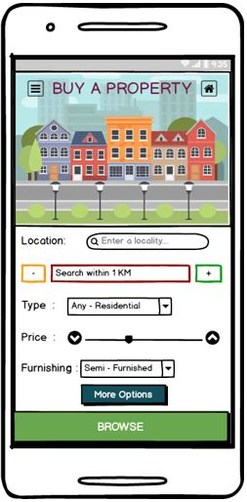 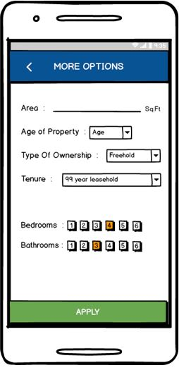

Figure 2.2.1‘Buy a Property page’ (Left) and

Figure 2.2.2 ‘More Options’ page (Right)

**Changes to be made:**

This issue can be addressed by redesigning the ‘More options’ page that allows us to stick with the static design of the application. The ‘More Options’ page seemed to miss a few buttons like going back to the Home screen or the previous page. We consider this as a design error which was overlooked during the project development.

We can also consider implementing a scroll down menu to reduce clutter as an alternative but it requires an overhaul of the entire design of the app and care needs to be taken not to interfere with the aesthetics of the final design.

While accessing the Register page (figure 2.2.3, below), the user seemed uninterested with the textual design. And the agent login option was not appreciated and felt out of context.

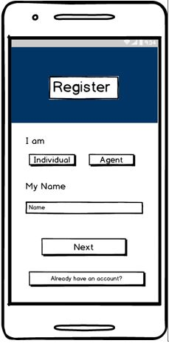 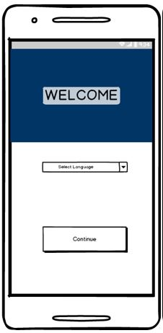

*Figure 2.2.3 ‘Register’ page (Left) and*

*Figure 2.2.4 ‘Welcome’ page (Right)*

The user also felt that the initial welcome page (figure 2.2.4, above) had no info regarding the application and they had a difficulty understanding the basic purpose of the app upon opening it. The app doesn’t display any kind of initial information keeping the user guessing about the basic service it offers.

**Changes to be made:**

The textual design needs to be improved and relevant information that provides necessary information about the app must be added. This can be achieved by displaying the required information on a new start up page rather than the ‘Welcome’ page. A new Welcome page can be used to register the users.

More images can be added to improve the aesthetics of the overall design.

Efficiency

The efficiency metric revealed that the clickable buttons were easily identifiable but the general flow of the app was inconsistent. Judging by the user review, too much of cluttered pages was a recurring problem that could have been avoided. Owing to this, there was a considerable delay in accessing the application. This can be observed in the ‘Buy a Property’ (Figure 2.2.1, above) and ‘Rent a Property’ (Figure 2.2.6, below) pages.

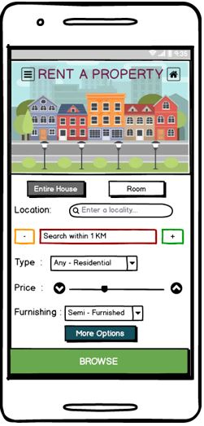

*Figure 2.2.6 ‘Rent a Property’ page*

In fact, too much content seems to be a consistent problem in some of the other pages like ‘Search by Interest’ (figure 2.2.7, below) and ‘For sale’ (figure 2.2.8, below) causing considerable delays in user navigation.

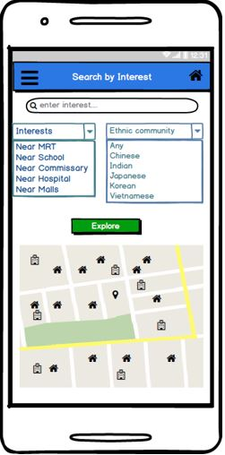 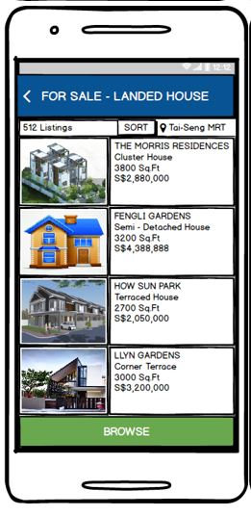

*Figure 2.2.7 ‘Search by Interest’ page (Left) and*

*Figure 2.2.8 ‘For Sale’ page (Right)*

One of the other factors affecting the effectiveness of the application is the non-availability of a clickable button to get back to the Home page. This caused a constant hindrance to the flow of the application and the user experienced continuous delays in figuring it out. This can be observed in the above image as well where the Home button is missing on the ‘For sale’ page.

**Changes to be made:**

The ‘Search by Interest’ page can be refined into a map based design rather than using scroll down texts which can be cumbersome for the users. Small buttons that offer various searches can also be incorporated into the map design that highlight the various areas of interest. The map layout should also include a graphic based legend that tells the user of the places they are looking at.

A more enhanced ‘More Options’ page will reduce the delays while accessing the ‘Rent a Property’ page. A consistent button theme must be incorporated on every page to avoid repeated clicks for the user.

Memorability

Upon testing the application for the first time, we went back to the same user after a week to check its viability for multiple uses. We wanted to look into the design features that were easily identifiable to the user. The User Interface was a standout. The user could easily relate to the UI, and the navigation was much smoother in during the second iteration. Even though the different pages had a lot of textual content, the ‘Call to Action’ buttons were easily highlighted with different colors and fonts making the overall navigation smoother and less cumbersome.

The user could also identify the basic design layout of the application. The header area was filled with images which helped in easy navigation. However, the inconsistent color scheme was also noted by the user. Some pages were displaying a different shade of blue as shown below. This highlighted the need for a consistent color scheme for the entire design.

Some of the features like using a map for searching was greatly appreciated by the user. This was a feature that had a positive impact on the user-friendliness of the application and enhanced its memorability.

**Changes to be made:**

The inconsistent color palette was a cause of concern as it was affecting the style and aesthetics of the final design. Some of the pages had a different shade of blue which should be avoided. A more polished and refined color scheme must be used to enhance user readability and acceptance. Too many bright colors need to be avoided.

Errors

The users made a few errors while accessing the application. Firstly, the users were unaware of the basic purpose of the application as there was no detail provided at the login page. They had to reconfirm with the tester before accessing it . However, the severity of the errors was quite minimal as the general layout and UI were quite user friendly. Most of the errors were related to misclicks on the part of the user.

One identifiable reason for these errors is the lack of consistency in the design of the app. The user could not figure which page some clicks will lead to. For example, the Home page (figure 2.2.9, below) has a simple layout with four buttons and doesn’t provide any other extra information leaving the user uninterested while accessing the application. Overall, the basic errors were caused because of over cluttering of text on some pages and unclickable buttons that lead nowhere. .

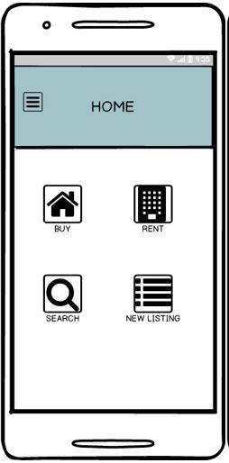

*Figure 2.2.9 ‘Home’ page*

**Changes to be made:**

The Home page must be updated with relevant details that enhance usability. Information must be added clearly describing the buttons of the page. The search button acts as a prominent feature of the app, and the search by interest page must be updated accordingly. The users should be given the option to register and login through this page as well. For a user using this app multiple times, the startup page can be skipped to improve efficiency and they can have a direct login from the Home page.

Satisfaction

The overall design of the app was appreciated by the user. The user interface and the layout were extremely user friendly. The color palette used, although inconsistent in parts, was unique and caused less strain on the user eyes. Bright colors were deliberately avoided and as a result the users were able to navigate quickly through the pages without any discomfort.

One of the most appreciated features is the ‘Search by Interest’ page. The users were happy to navigate through the various options or select their place of interest directly on the map. This feature enhanced the usability of the app and made it a standout feature as compared to other similar apps in the market.

However, some features like agent login and asking the FIN number along with other details was under appreciated. People may not willing to provide such sensitive information even though beneficial to the overall functionality of the app.

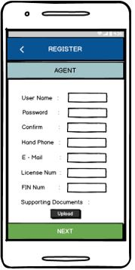

*Figure 2.2.10 ‘Register Agent’ page*

**Changes to made:**

More consistent color scheme should be used throughout the application. Text boxes must be properly fitted into the pages and relevant information provided within them. Agent login may not be required and needs to be assessed based on the usability testing. Details like FIN number must be excluded to maintain user acceptability.

Consistent scheme must be implemented and menu buttons must be incorporated on every page to provide easy navigation. Text be replaced by imagery and graphic design to enrich the user experience while accessing the app.

# **3. Technical Report**

## **3.1 Logical Data Flow**

The following diagrams illustrate the basic flow of the application, from the start where users can register and log in, to the end result of browsing, listing, renting or buying a property.

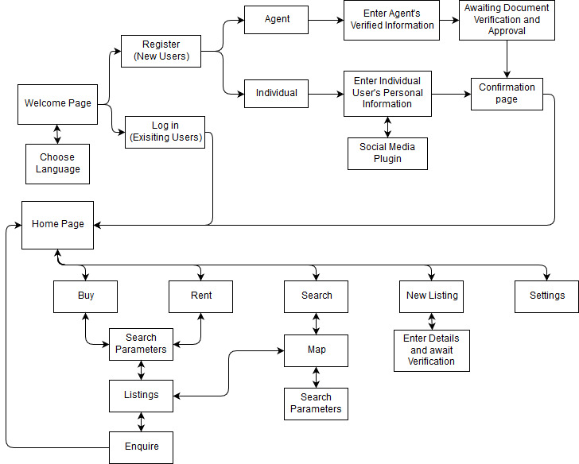

*Figure 3.1.1 Logical Data Flow (Before)*

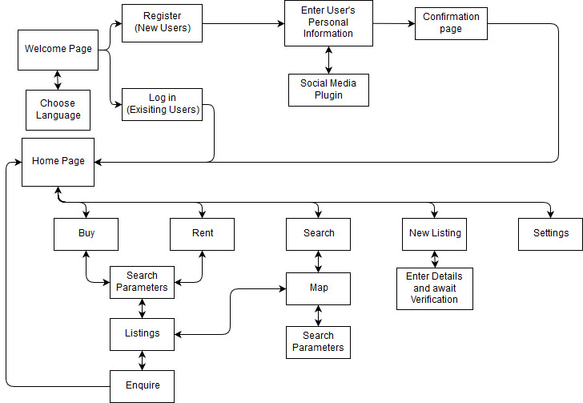

*Figure 3.1.2 Logical Data Flow (After)*

Figure 3.1.1 (Above) is the Logical Data Flow diagram of the application at the end of the CP2408 Design Thinking assignment.

After our most recent round of usability testing, the decision to exclude the “agent” option of the application has lead to the merging of the

registration path, as shown in Figure 3.1.2 (Above).

We will be adhering to the Logical Data flow from Figure 3.1.2 in subsequent iterations of the application, barring any further changes.

## **3.2 Design Diagram**

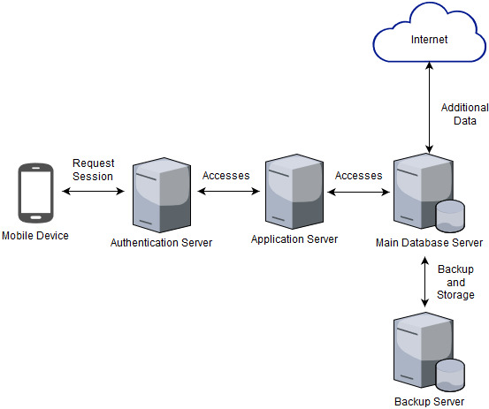

*Figure 3.2.1 Technical Design Diagram*

This diagram is a brief overview into the technical structure of our application and various runtime processes. Each individual component is discussed in-depth in the following sections.

## **3.3 Technical Specifications**

This section will contain information pertinent to the core technical functionality of our application and it’s back-end processes thereof.

### **3.3.1 Computing Platform and Programming Language(s)**

Our team will be developing our application using Android Studio (3.0.1) by Google which supports Java, C/C++ and the Android-proprietary Kotlin programming language. Secondary XML coding will also be performed to handle the UI elements of our application. Although we explored several options in terms of platform popularity and readily accessible SDKs, the above mentioned choices provided us with the most potential target audience based on statistical data and market share (*refer to References, point 1 and 2*) whilst also having the team accustomed to the coding languages.

iOS would be our secondary choice as we would have to familiarize ourselves with the proprietary Swift programming language developed by Apple using the Xcode IDE and Cocoa Touch to build the UI elements. Further given that iOS/ OS X development can only be performed on a fairly powerful Mac device, our initial investment would be considerably larger than the Android alternative.

### **3.3.2 Application Server**

An application server is an intermediary layer between the client and the core server that provides APIs and other functionalities to improve accessibility and streamline access to the database.

In our case, we will be utilizing Google’s FCM (Firebase Cloud Messaging) Server in tandem with its Cloud Functions Server to provide access to our Cloud Hosted Database and retrieve information. Our client application will be communicating with this application server to perform functions and retrieve data that will be displayed on their device.

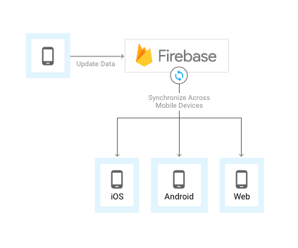

*Fig 3.1. Firebase Application Server Concise Data Flowchart*

### **3.3.3 Database Server**

As our initial investment is low and we are effectively a startup, we will be utilizing Google’s Firebase Real-time Database and Cloud Firestore for our initial database deployment as they provide an excellent Cloud Hosted JSON and SDK environment to store our data for free. However since there are quotas limiting our use of Firebase and their free services (*refer to Reference, point 3*), if our application experiences a tremendous growth rate, we must consider opting for our own Node.js Server in tandem with a mongoDB server to store our data as it is quite readily scalable.

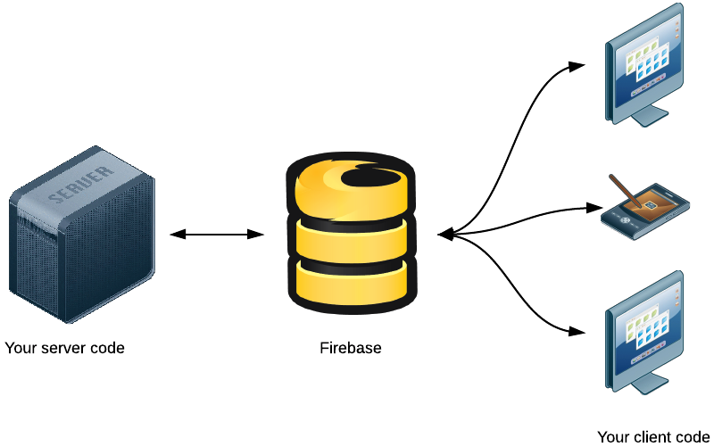

*Fig 3.2. Firebase DB Server processing flowchart*

The Firebase Real-time Database is a cloud-hosted database where data is stored as JSON and synchronized in real-time to every connected client. Whereas the Cloud Firestore provides offline storage using an easily scalable NoSQL DB that provides offline storage and connectivity between clients. Therefore, if we later decide to build our application on another platform such as iOS, all of our clients share one Real-time Database instance and automatically receive updates with the newest data through Google’s Firebase dependency libraries.

### **3.3.4 Authentication Server and Access Requirements**

For our application, we will be making use of FirebaseUI or SDK based authentication on our respective Google Firebase server. Since we are a startup and our application is new, we aim to provide third-party login via popular sites such as Google, Facebook etc. is our goal.

Luckily, our Firebase Authentication server supports OAuth 2.0 and OpenID 2.0 protocols, hence allowing us to provide easy access to our services while verifying their identity and maintaining their session using industry standard practices. However if we encounter technical limitations, we will still be providing basic login functionality to track user session and maintain their unique connection state to our server.

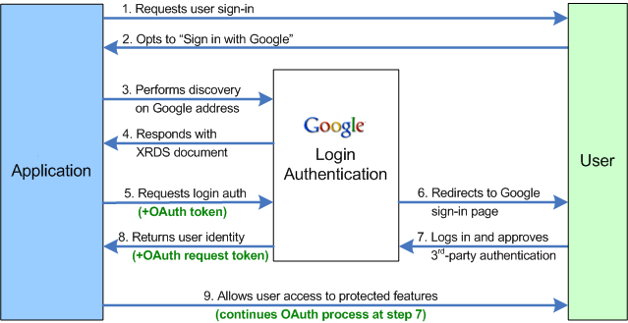

*Fig 3.3. OpenID 2.0 Login protocol diagram*

From our client’s perspective, it is a simple 2 click process to access our services and setup their profile instead of time consuming manual procedures. However, we will also provide the standard account creation template to cover the entire demographic of users. The next time our clients login to our application, all that needs to be done is to enter their user id and password or re-verify their identity using OpenID via their linked Google, Facebook etc. accounts.

### **3.3.5 Storage Needs (exclusive of DB)**

Our application aims to store minimal media files unlike social media platforms, hence our media data storage will be limited to only several files per user such as profile picture, travel document image and identity proof image which are all highly compressed and do not require constant or readily-available access.

Now to get an estimate of the data storage required, at a conservative 100 unique users per month for the first 12 months, assuming an average of 12 images per user at standard compression rate of 50 kb each (600 kb) and further 424 kb of additional reserve data per user, gives us 1MB (1024 kb) per user per month. So our total for user data sums up to ~ 1.17GB of data annually based on our currently planned functionalities. *(Fig 3.4, below)*

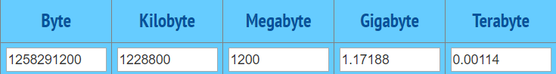

*Fig 3.4. Annual User Data Storage Required*

Other media such as the live MRT map, bus routes etc. might also be pulled from authorized Government servers and stored on our own storage server to provide faster access to our clients. We can account for all of this extra media generously with around ~1.5GB of data for our first 12 months. Therefore, this coupled with our user specific data can be approximated to be **~2.5GB annually** *(Fig 3.5)*. Since Firebase initially provides us with 5GB of data storage for free, we can be prepared for explosive growth or develop additional features that may use more of our nearly ~50% readily available data storage space. Assuming a growth rate of 10% per year thereof and several additional features being implemented, we can safely assume at least a 2-year period after which we can either choose to upgrade our Firebase server or migrate to a self-hosted server.

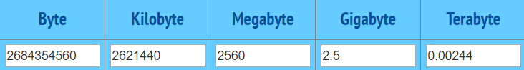

*Fig 3.5. Total Annual Data Storage Required*

### **3.3.6 Data Protection**

As our application and user data will be stored under the Google Cloud, our data privacy policy will be of the same nature. Google is compliant with Data Protection acts in most countries around the world (*Reference, point 4*) with the most prominent ones being the Privacy Shield(EU-US/ US-Swiss) framework, the EU Data Compliance Act and Singapore’s Personal Data Protection Act (PDPA). Since our team is allowed to create database buckets at any of the above three server locations on Firebase, our clients can be assured that their data is being kept secure and under government oversight within Google’s Database servers.

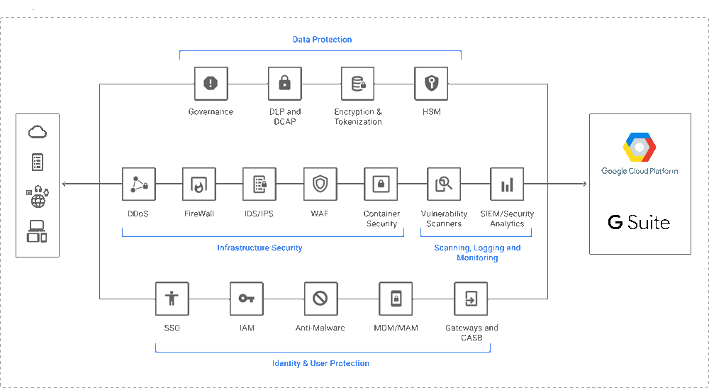

*Fig 3.6. Google’s Data Compliance framework*

### **3.3.7 Application Dependencies**

Dependencies in software programming is a common term referring to the functionality of a particular module of the primary application partially relying on a secondary application to retrieve its data to produce the output. To enable our application to perform key functions, several dependencies will be established on Firebase to handle the various requests and processes between our server and the client.

Some of the Dependencies which may be used as functionalities are added to our application are listed below-

|  |  |
| --- | --- |
| **DEPENDENCY** | **FUNCTION** |
| com.google.firebase:firebase-core:11.6.2 | Analytics |
| com.google.firebase:firebase-database:11.6.2 | Real-time database |
| com.google.firebase:firebase-firestore:11.6.2 | Cloud Firestore |
| com.google.firebase:firebase-storage:11.6.2 | Storage |
| com.google.firebase:firebase-auth:11.6.2 | Authentication |

*Fig.3.7. Potential Application Dependencies*

# **4. Wireframe of the project**

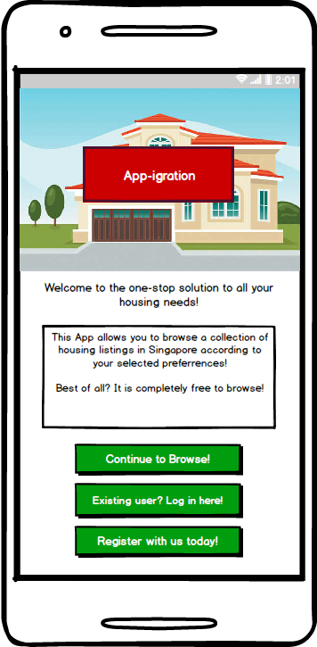 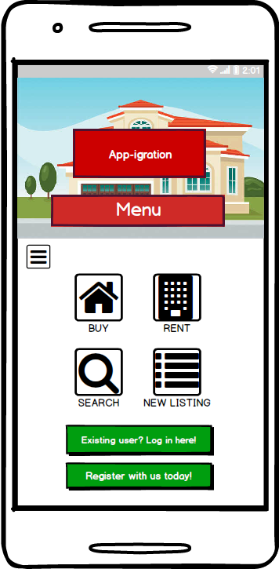 *Figure 4.1 Start Screen (Left) & Figure 4.2 Home Screen (Right)*

**Justification**

The initial screen that greets a user, the Start screen (figure 4.1, above) has been revamped to clearly display the purpose of the application, as well as providing options to log in, register an account, or to start browsing the application immediately. This follows the comment that the restriction of having to login or register first being off putting.

The Home screen has been redesigned to be the Menu of the application, and subsequent screens will have the option of allowing the user to return directly to this screen. The colour scheme has been altered to provide a more aesthetically pleasing experience for the user.

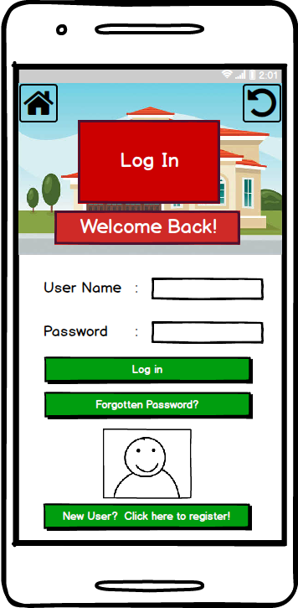 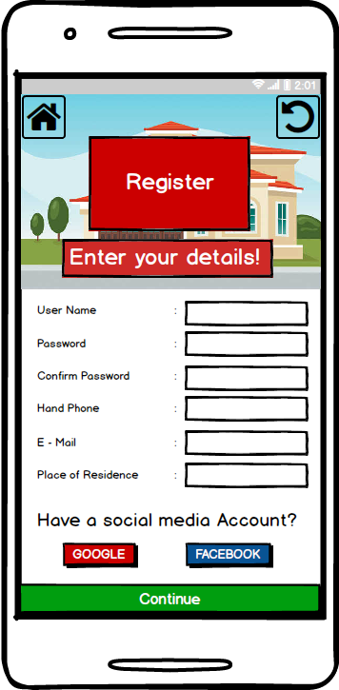

*Figure 4.3 Login Screen (Left) & Figure 4.4 Registration Screen (Right)*

**Justification**

The Login screen (Figure 4.3, above) has been redesigned to better reflect its purpose, better stating the options to login, register, or resetting a forgotten password.

The Registration screen (Figure 4.4, above) has been changed to allow for one singular registration method, rather than having separate sections for agents and individuals. This will instead be under personal information, where the user can update accordingly after creating an account.

Options to return to the menu page and the previous page has been added as well.

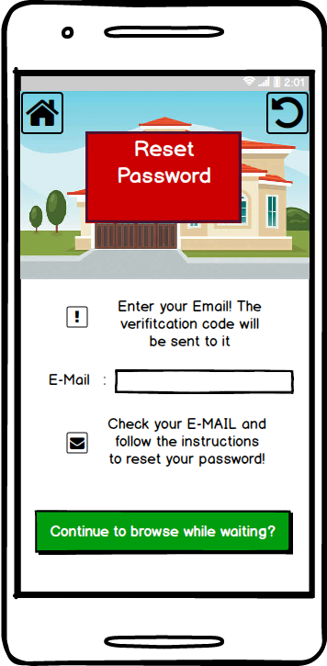 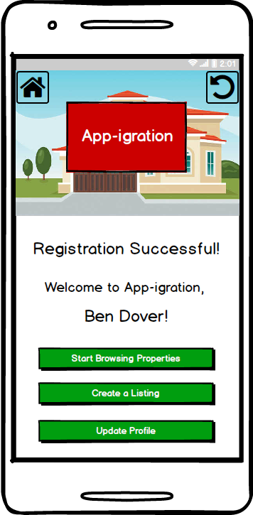

*Figure 4.5 Reset Password Screen (Left) & Figure 4.6 Successful Registration Screen (Right)*

Justification

The reset password screen (Figure 4.5, above) has been updated to be more aesthetically pleasing, and provides the user with the option to continue browsing while waiting for the ‘reset password’ email, improving the functionality of this screen.

The successful registration screen (Figure 4.6, above) has been updated to provide the user with options to proceed to various other screens in the application, rather than a single path before.

Options to return to the menu page and the previous page has been added as well.

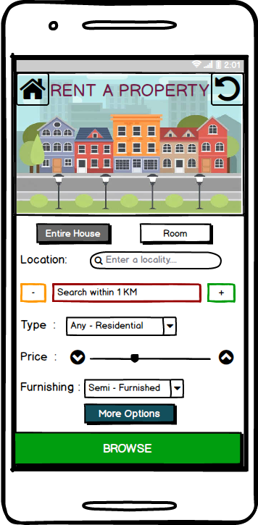 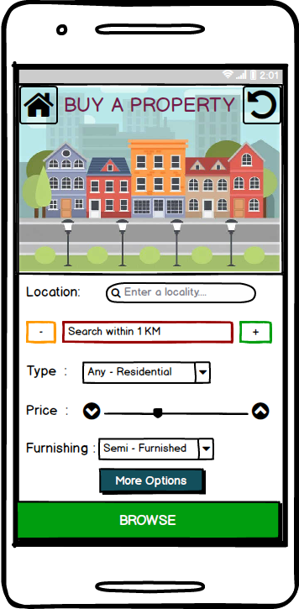

*Figure 4.7 ‘Rent a Property’ Screen (Left) & Figure 4.8 ‘Buy a Property’ Screen (Right)*

Justification

The Buy and Rent pages have an enriched look now. This design fits the overall static layout of the application. Scroll down buttons were avoided and a new enhanced ‘More Options’ page improved the functionality of the above pages. A ‘return’ button has been incorporated to provide easy navigation.

Options to return to the menu page and the previous page has been added as well.

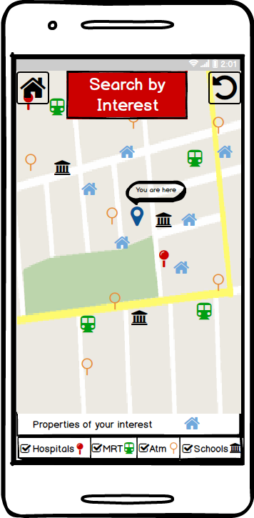 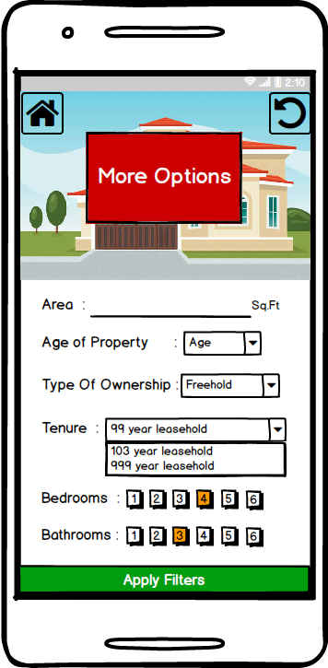

*Figure 4.9 ‘Map Search’ Screen (Left) & Figure 4.10 ‘More Options’ Screen (Right)*

Justification

The ‘Search by Interest’ page has gone a complete overhaul. All the previous textual content has been replaced with a graphical map interface. Appropriate icons are used as clickable buttons at the bottom of the page and provides quick navigation.

The user can easily filter for the nearest MRT or hospitals on the map. This will provide them a complete understanding of the surroundings to fit their needs.

The ‘More Options’ page has a ‘return’ button that will take them back to the previous screen further improving navigation.

**Noted Changes:**

Some of the pages like Agent Registration and Login were excluded from the final design as they seemed tangential to the overall usability if the application.

# **5. Personas of users.**

## **5.1 Mr Mike Litoris**

Name: Mike Litoris Sex: Male Age: 53

Nationality: Swedish

Occupation: Financial Analyst



*Figure 5.1.1 Imagined illustration of Mr Mike Litoris*

Background:

Working in finance for a large banking corporation the job requires Mike to travel a lot, and on occasions immigrate to new countries. Mike has spent a lot of time outside of his birth country.

On numerous occasions Mike has had to stay in countries for 3 to 6 months as part of a training management team. As a single male this has not had a tremendous negative impact on his life in regards to family matters.

Requirement:

Constantly immigrating to new countries and frequently visiting countries for prolonged periods Mike requires an application to assist in short term accommodation close by to his workplace as purchasing a vehicle would be financially irresponsible.

As for being new to a country, the application would benefit a lot by having information regarding local tourist sites for visiting, and local spots for shopping, buying groceries and other points of interest.

## **5.2 Mr Ben Dover**

Name: Ben Dover Sex: Male Age: 37

Nationality: British

Occupation: Regional Manager for Continental



*Figure 5.1.2 Imagined illustration of Mr Ben Dover*

Background:

Ben is established in his line of work, and has been selected to migrate to Cape Town to take over another regional managers position. This opportunity will require the relocation of himself, partner and 3 children.

The move will put a lot of pressure on Ben, specifically because of schooling for the children, and to ensure work for his wife when they arrive. Along with the transition to a new country the family need to find a house before moving, and help migrate the family dog, which the children cannot live without.

Requirements:

In order for a smooth family relocation to a foreign country, a specific set of requirements are to be met. A quick search for an appropriate neighborhood with easy access to a primary and high school is top priority, the neighborhood should also be in close proximity to the office for Ben.

Being the first time moving out of England the family are unfamiliar with culture, food and entertainment. If these elements can be fulfilled the transition will be effortless and automated. Location and convenience is important, if an application can cater for appropriate search results with a set list of preferences it would suffice, along with extra information about schools, local parks, and shopping centers.

# **6. References**

1. <http://gs.statcounter.com/os-market-share/mobile/singapore>
2. <https://www.cnbc.com/2016/11/03/google-android-hits-market-share-record-with-nearly-9-in-every-10-smartphones-using-it.html>
3. <https://firebase.google.com/pricing/>
4. <https://privacy.google.com/businesses/compliance/#>
5. CP2408 Assignment 1 & 2 (Udaya’s Group)
6. https://[www.draw.io](http://www.draw.io) (Logical Flow diagrams)
7. Wire Frame created using Balsamiq software (https://balsamiq.com/)
8. <https://www.behindthename.com/random/> (Randomised names for User Personas)
9. <https://www.storyboardthat.com/> (Generated Figures 5.1.1 & 5.1.2)

# **7. Appendix**

## **7.1 Usability Assessment by our own team.**

**Learnability**

|  |  |  |  |  |
| --- | --- | --- | --- | --- |
| **Very Easy** | **Easy** | **Neutral** | **Hard** | **Very Hard** |
|  | X |  |  |  |

The basic design of the app is user-friendly. The buttons are easily identifiable and help in navigating through the various elements in the set design. The colour palette greatly enhances the user’s experience while accessing the application. The pictures used will give an overview of the accommodation that is being offered.

We believe the app has a good navigation system that allows the user to access all the features of their choice. The application automatically tells the user to register and login into their account. The calls to action have been identified as clickable buttons. The app is self-explanatory. The user can locate a house on the map based on their chosen preferences.

**Efficiency**

|  |  |  |  |  |
| --- | --- | --- | --- | --- |
| **Very Quickly** | **Quickly** | **Neutral** | **Slowly** | **Very Slowly** |
|  |  | X |  |  |

The app itself is a navigation and search heavy layout. The app is not used on a daily basis, and is tailored towards being able to specifically find what you are looking for by addressing filters and searches. Navigation is simple, but finding what the user is looking for takes care and time.

The app focuses on specifications, and precision. The user looks for specifics and doesn't need to navigate quickly through it all, the app design itself is simple and allows for easy understanding.

**Memorability**:

|  |  |  |  |  |
| --- | --- | --- | --- | --- |
| **Very Easy** | **Easy** | **Neutral** | **Hard** | **Very Hard** |
|  | X |  |  |  |

Given that the application is meant to provide customers with constant updates on their properties of interest, their return experience with handling our application design will be quick and efficient. The primary pull or stand out feature of our application will be that of prioritizing the customer’s interest in the various modules and adapting the layout of the application around their preferences rather than forcing the users into redundant menus. This minimalistic layout approach will be readily accessible and decluttered to provide users with a friendly interface. All these factors contribute to users being able to easily recollect and navigate our application with ease.

All of our application modules will stick to the minimalistic design philosophy that we have employed to display the most prominent information to the customer as per their interests. We will also collect usage statistics and feedback from the users to gain better insights further into the lifecycle of the development of our application.

**Errors**

**Number of Errors**

|  |  |  |
| --- | --- | --- |
| **High** | **Average** | **Low** |
|  |  | X |

Majority of the application has been polished, and the application itself would be able to meet consumer expectations were it to be released now. The application can be improved through several more iterations of user testing, although no major changes to the designs and features would be implemented.

**Severity of Errors**

|  |  |  |
| --- | --- | --- |
| **Severe** | **Average** | **Slight** |
|  |  | X |

Again, there are no foreseeable major problems with the design and features of the application. Most of the possible changes are dealing with the aesthetics of the application, and no major overhaul of the design or features of the application is required.

**Ease of Recovery**

|  |  |  |
| --- | --- | --- |
| **Easy** | **Average** | **Hard** |
| X |  |  |

The navigation of the application is straightforward, can will be displayed at the top of each page that is displayed. Therefore any accidental misdirects can be rectified simply by re-clicking on the intended destination.

Any wrong information about created listings can be edited easily by the listing person, simply through a button in the user interface. The user can also choose to delete and re-add the listing if he wants to.

**Satisfaction**

|  |  |  |  |  |
| --- | --- | --- | --- | --- |
| **Very Pleasant** | **Pleasant** | **Average** | **Below Average** | **Very Poor** |
|  | X |  |  |  |

The design is simple and provides ample information that is organised with minimal clutter. This allows the user to view these details with ease and intuition, allowing him to find the desired remarks/notes to allow for a favourable listing to be found. Navigation is simple and straightforward, and the user should not have any problems finding the correct information tab to proceed with their objectives.

The design can be improved by further compressing the information into smaller bite sizes if desired.

## **7.2 Usability Assessment by another team.**

**Learnability**

|  |  |  |  |  |
| --- | --- | --- | --- | --- |
| **Very Easy** | **Easy** | **Neutral** | **Hard** | **Very Hard** |
|  | X |  |  |  |

The user was able to understand the general design, and able to navigate using logic, and understanding of what they wanted to do.

The design itself is practical and very in depth, as there are no missing features or pages which the user will want to see or navigate.

**Efficiency**

|  |  |  |  |  |
| --- | --- | --- | --- | --- |
| **Very Quickly** | **Quickly** | **Neutral** | **Slowly** | **Very Slowly** |
|  | X |  |  |  |

The user was able to quickly look at what they wanted, and fill in preferences to easier obtain desired results within the app. The user was able to navigate with ease, and land on a page they wanted to view.

Although the design is very in depth, the user took some time to get use to it, as there was clutter, and some pages that could have been merged into less pages. Although after spending some time with the app the user quickly figured out the general flow and logic.

**Memorability**

|  |  |  |  |  |
| --- | --- | --- | --- | --- |
| **Very Easy** | **Easy** | **Neutral** | **Hard** | **Very Hard** |
|  |  | X |  |  |

The user was able to navigate through the app, but it took some time for them to figure out what they wanted to do, and what they needed to do. After somewhat time the user was able to navigate more easily and off of memory.

The design of the app is not supposed to be a quick glance app where you only want one form of information. This app rather helps identify information that is useful to the user, and specific instructions need to be executed to get the correct outcome for the user.

**Errors**

**Number of Errors**

|  |  |  |
| --- | --- | --- |
| **High** | **Average** | **Low** |
|  |  | X |

When using the app the user took their time to look through the menus, and see what they wanted to do, and clicked and filled in accordingly. Most errors were made, by user error.

**Severity of Errors**

|  |  |  |
| --- | --- | --- |
| **Severe** | **Average** | **Slight** |
|  |  | X |

The user’s initial using was prompt, and almost no errors were reported, this enables very little severity of the errors.

**Ease of Recovery**

|  |  |  |
| --- | --- | --- |
| **Easy** | **Average** | **Hard** |
| X |  |  |

Misclicks were happening, the user simply backtracked and was able to recover their navigation.

**Satisfaction**

|  |  |  |  |  |
| --- | --- | --- | --- | --- |
| **Very Pleasant** | **Pleasant** | **Average** | **Below Average** | **Very Poor** |
|  | X |  |  |  |

The overall design was very indepth, and the user was able to navigate to any point that they wanted to be, the user was able to get results in real time, and interact with what they wanted.